**Apps to be used in Android Mobile Phones for IoT Workshop**

We are going to use two apps in Andoid phone. Both apps are completely free. Please download them from Google Playstore in your mobile phone.

1. ArduDroid
2. AMR_Voice (BT Voice Control for Arduino)
3. Blynk

How to Install:

1. **ArduDroid**: Simply search for ArduDroid in Google Playstore in your Android Smartphone. First option that says ArduDroid, simply touch on it to open it. Once it open, Click on Install. Wait for it to download & install it in your android smartphone.

This app will be used for **Project 5- Android based device control**. Please upload the **Ardudroid program in Arduino** to test it with your Android Smartphone which is there in Program folder.

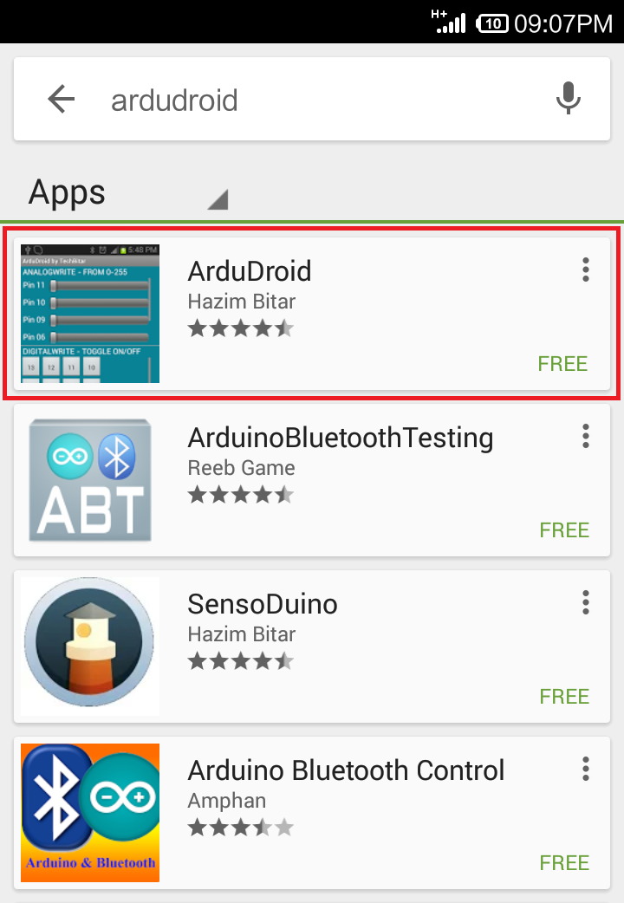

1. **AMR_Voice:** Simply search for AMR_Voice in Google Playstore in your Android Smartphone. First option that says BT Voice Control for Arduino, simply touch on it to open it. Once it open, Click on Install. Wait for it to download & install it in your android smartphone. This app will be used for **Project 6 & 8- Android based device control**.

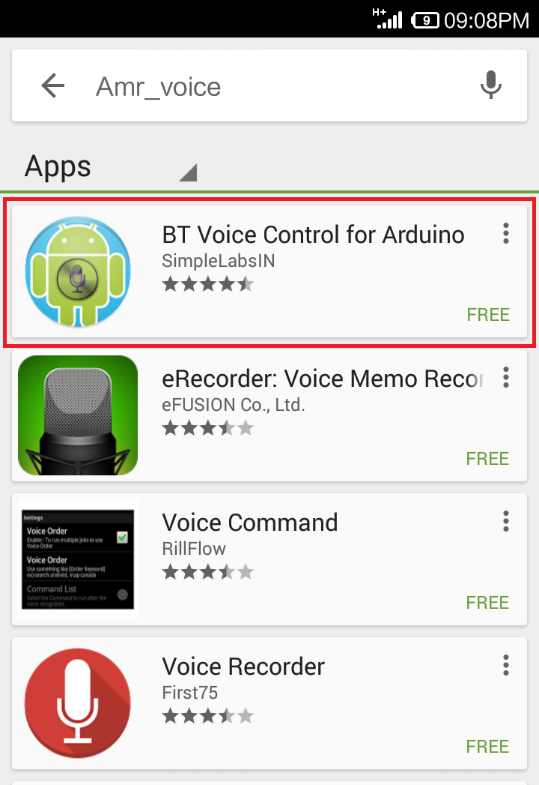

1. **Blynk:** Search for **Blynk** App on Google Playstore & Install it.